**E-commerce Domain**

**Grocery Store**

|  |  |  |
| --- | --- | --- |
| Date | Prepared by / Modified by | Team Members |
| 29th NOV 2021 | Team C | Priyanka  Amrutha  Kavya  Manoj  Rohith  Lohitha |

Table of Contents

1 Introduction 3

2 Scope of Change 3

3 List of impacted modules 3

4 Design and Detailed technical updates 4

4.1 Process model 4

4.1.1 Use case Model 4

4.1.2 Sequence diagram 4

4.2 Proposed user Interface design 4

4.3 Database design changes 4

4.4 Refactoring related changes 4

4.5 Construction strategy and re-use 4

5 Details of Alternative Design Approach 4

6 Other Technical changes 5

6.1 Automation tasks  / changes 5

6.2 CI / Build relates tasks / changes 5

6.3 Non-functional related changes 5

7 Additional details 5

7.1 Open Questions / clarifications / Assumptions 5

7.2 Additional notes to technical team 5

8 References 5

# Introduction

Application to be developed is an E-Commerce Web Application for Grocery Store. The product will provide platform for several individuals and companies to sell their products. The application is intended to be small and resource efficient. Application will implement all of the CRUD operations on database. The goal of our application is to provide a quick and easy to use interface for all users. The system should be available to be used with the least number of variable factors that can affect it.

This shopping application has 2 users:

1. Admin:

An admin can update(add/modify/delete) stock as and when he wishes. The Admin can view product information. The Admin has privileges to decide about the pricing of the products.

1. User:

User can able to buy the products from the application. The user will be provided with features like sort, filter, on the home page, to ease the search of the product. Sorting can be done either alphabetically on the basis of product name or according to the product price (Low to High and High to Low). Filtering can be done with respect to price or brand of the product.

Online grocery refers to a grocery store that allow private individuals and businesses to purchase groceries and grocery product online. That is actually a delivery charge for this service Online grocery delivery service are available throughout **India**.

# Scope of Change

1. User can able to purchase the grocery products from the application and admin can able to modify the application.
2. This system has email validation through mail.

# List of impacted modules

These are the modules used in this application :

1. **Log-In:** The user can login using email and password. If the user fails to enter correct email and password, the Forgot Password option can be clicked which will allow the user to reset the password. The user can purchase a product, compare or add to wishlist only when he/she logins.
2. **Sign-In:** Users should enter their personal details like name, email id, address, mobile number. The user must choose a password for himself which will be used for future logins. The password will be encrypted before being fed in the DB. After successful registration, the user can login to the application.
3. **User:** The user will be provided with features like sort, filter, on the home page, to ease the search of the product. Sorting can be done either alphabetically on the basis of product name or according to the product price (Low to High and High to Low). Filtering can be done with respect to price or brand of the product.
4. **Home:** It’s a dashboard look for the website.
5. **Category:** It contains the categories like Fruits& Vegetables, Staples, Dairy & Bakery, Snacks, Beverages, Personal Care, Home Care
6. **Search:** You can search the product from the application.
7. **Review**: Reviews of the Customers and their Ratings.
8. **Cart**: You can add products to the cart and you can see them in the cart section
9. **Contact Information:** You can contact the support team to clarify the doubts.
10. **Customer Services:** You can able to see about our application and terms & conditions and privacy policies.
11. **Collections**

**a. Users:** It contains User information.

**b. Products:** It contains Product Information.

**c. Orders:** It contains Order information.

# Design and Detailed technical updates

## Process model

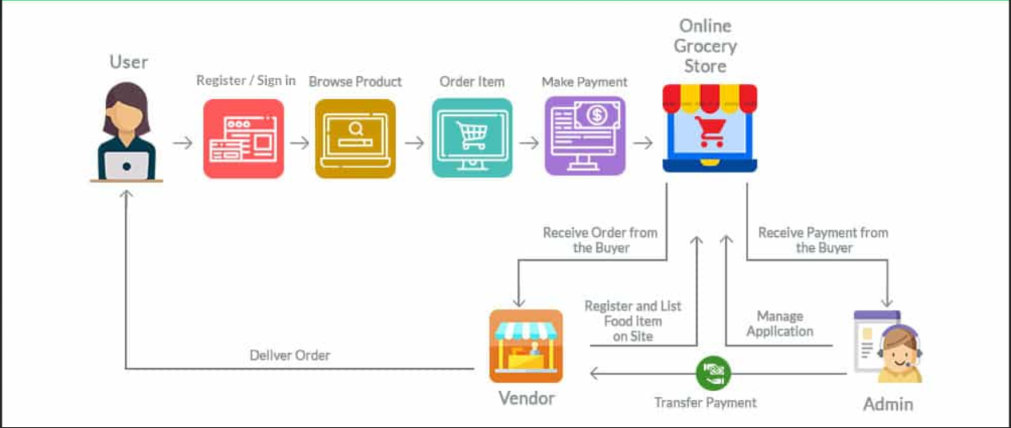

|  |  |
| --- | --- |
| Brief Description | Customer Registration (Sign-Up) |
| Basic Flow | This use case describes how a client register in to the system   1. The client has to register himself into the system. 2. After the successful registration, client will get a success message. 3. The following information is required during registration.  * First Name * Last Name * Email * Mobile Number * Password |
| Alternate Flow | The system will validate the information provided. If any invalid data is found, the input form will be redirected with error message. |
| Validation | 1. First name and Last name must be required. 2. Email should be valid. 3. Mobile number must be in numbers and contain 10 digits. 4. Password must contain at least one number, one uppercase and one lowercase and at least 8 or more characters. |
| Pre-Conditions | User should have network access and Browser with latest updates. |
| Post-Conditions | Success message should be shown. |

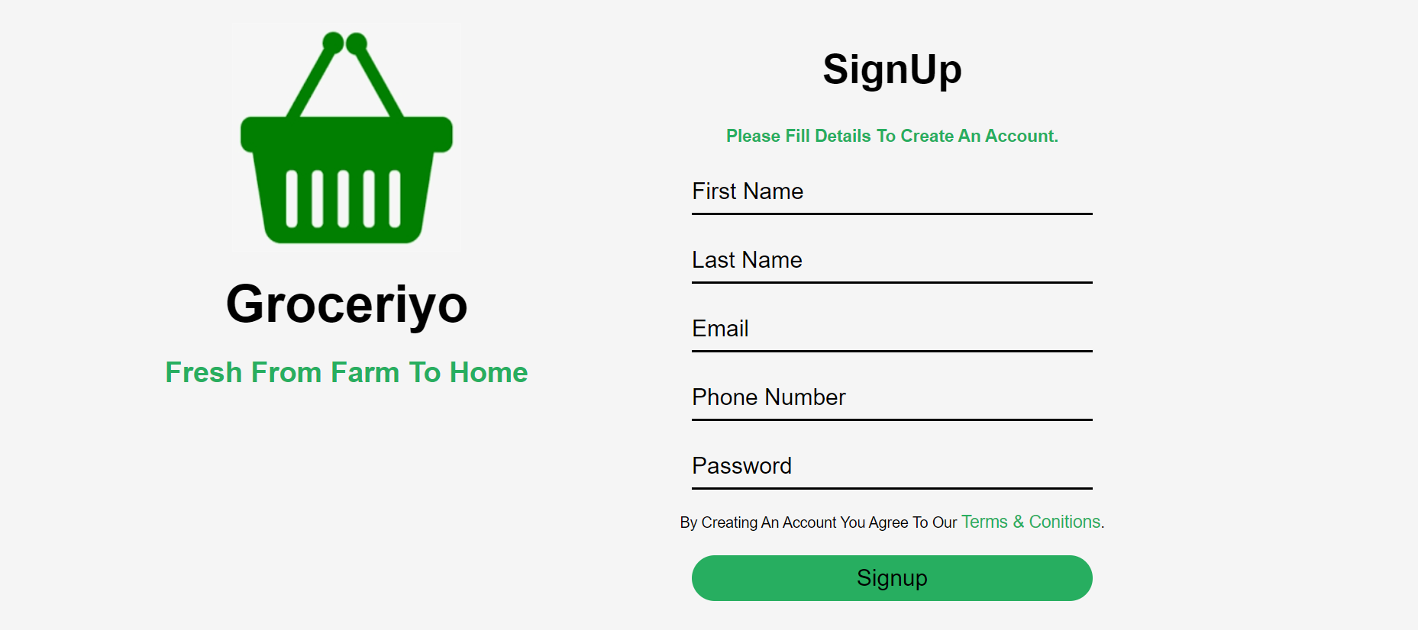

|  |  |
| --- | --- |
| Brief Description | Login |
| Basic Flow | This use case describes how a user log-in in to the system   1. The user has to register himself into the system. 2. After the successful login, user will be taken to the appropriate landing page. 3. The following information is required to login.  * email * password |
| Alternate Flow | The application will validate the credentials provided. If credentials are invalid, login form will be redirected again with error message. |
| Validation | 1. Valid email 2. Valid password |
| Pre-Conditions | User should have network access and Browser with latest updates. |
| Post-Conditions | Landing page has to be displayed. |

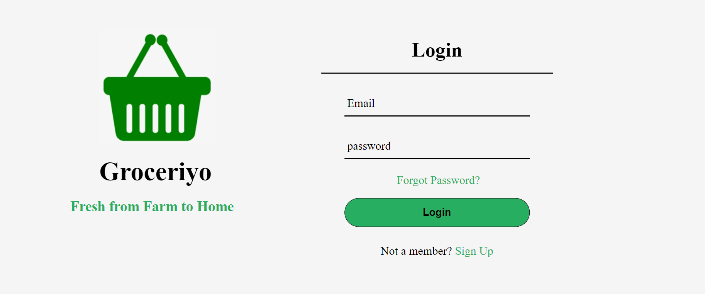

|  |  |
| --- | --- |
| Brief Description | Dashboard (Homepage) |
| Basic Flow | This use case describes how the homepage looks like  1. The user can see our features.  2. He/she can click on the products which they want to order.  3. After the successful login, user will be taken to the appropriate landing page.  4. The following has to be done to move into the home page.   * Sign-Up * Log-In   5.User can able to see reviews, products and categories. |
| Alternate Flow | Not Applicable |
| Validation | Not Applicable |
| Pre-Conditions | User should have already logged into the system. |
| Post-Conditions | Not Applicable |



## Architecture Diagram

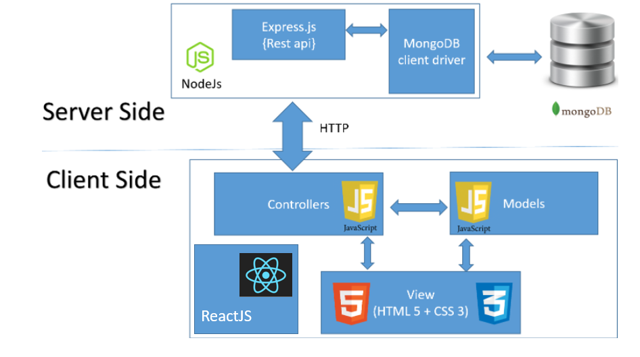

**Presentation Layer:**

This layer consists of all UI components.

* Export component: The plug-in is used to export the reports in pdf format. It helps to reduce the workload on the web/ application server.
* Validation component: All basic level data validations should be done at UI level.
* Report component: All reports to be generated to the user, will be processed and generated at the browser end.
* Resources: All HTML/CSS/ images, which are required for the page design.

**Data Access Layer:** Using MongoDB and NodeJS we can access the database.

### Sequence diagram

Admin

User

Database

User Registration Invalid

Invalid

Error Message Error

Valid

Success Message Success

Login Form Invalid credentials

Error Message Error Invalid

Valid Credentials

User home page Success

## Proposed user Interface design

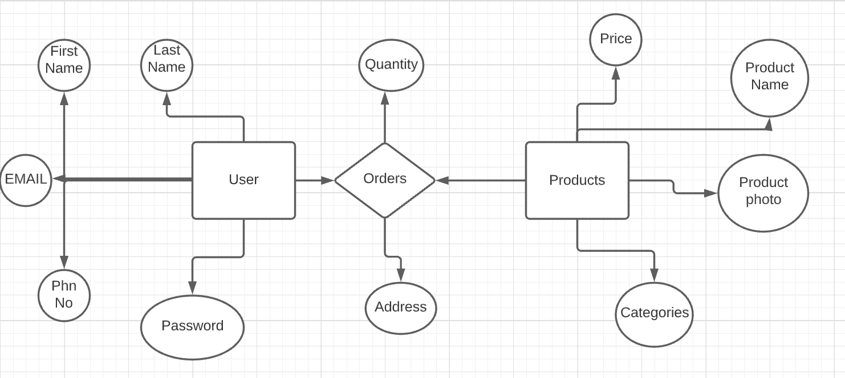

# Other Technical changes

## CI / Build relates tasks

<If the story requirements are about implementation of continuous integration or build, update the details to be done here>

## Non-functional related changes

**<Non-functional requirements related to response time, System load or Network load>**

# Additional details

## Open Questions / clarifications / Assumptions

<Mention the details of any open technical questions/clarifications or assumptions made, pertaining to story >

# References

Google, GitHub, YouTube